Installing a Linux VM on Mac M1/M2

This tutorial will walk you through each step of getting Linux 20.04.6 installed as a virtual machine on your Mac.

Prerequisites: UTM, Linux ISO file, and an M1/M2 Mac with 20GB of free disk space.

FAQ
My VM says “Display output is not active.” Help!
Try clicking on the VM. If nothing happens, please wait for the VM to load. If it doesn’t load after a few minutes, reboot the VM.
My VM says “Guest has not initialized the display (yet).”
Delete the VM from UTM, then create a new one following the steps below.
How do I know if my Mac has an M1/M2 or Intel chip?
Click on the Apple Logo in the top left > About this Mac.
My cursor isn’t showing!
Force Quit UTM, then relaunch it.
My cursor is trapped in the VM Window!
Press CTRL + OPTION to release your cursor.
I would like to plug in a USB device to my VM.
In the UTM window, stop your VM. Then click on Settings > Input > Share USB devices from host

- Download UTM for free from their website. Downloading UTM from the App Store will cost $10.
- Open UTM.dmg and install it by dragging the UTM icon into the Applications folder.
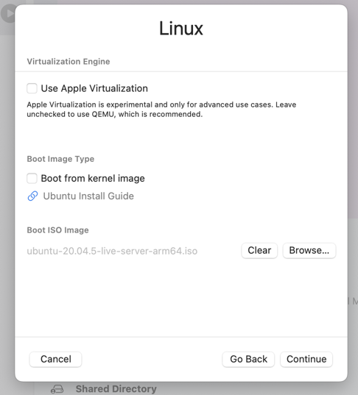
- Download the Linux 20.04.6 ISO File.
Figure A: Step 5
- Open UTM and create a new VM. Select “Virtualize” > “Linux”
- Under Boot ISO Image, click Browse. Select the Linux ISO file you downloaded, then Continue.
- Assign 4096 MB (4GB) of memory to your VM.
- Assign 20GB of disk space to your VM.
- Give your VM an interesting name, double check the settings, then click Save.
- Click on the start button next to your VM to launch it. Select “Install Ubuntu Server” > English.
- You will be notified that a new version of the installer is available. However, please select Continue without updating to install the correct version of Ubuntu.
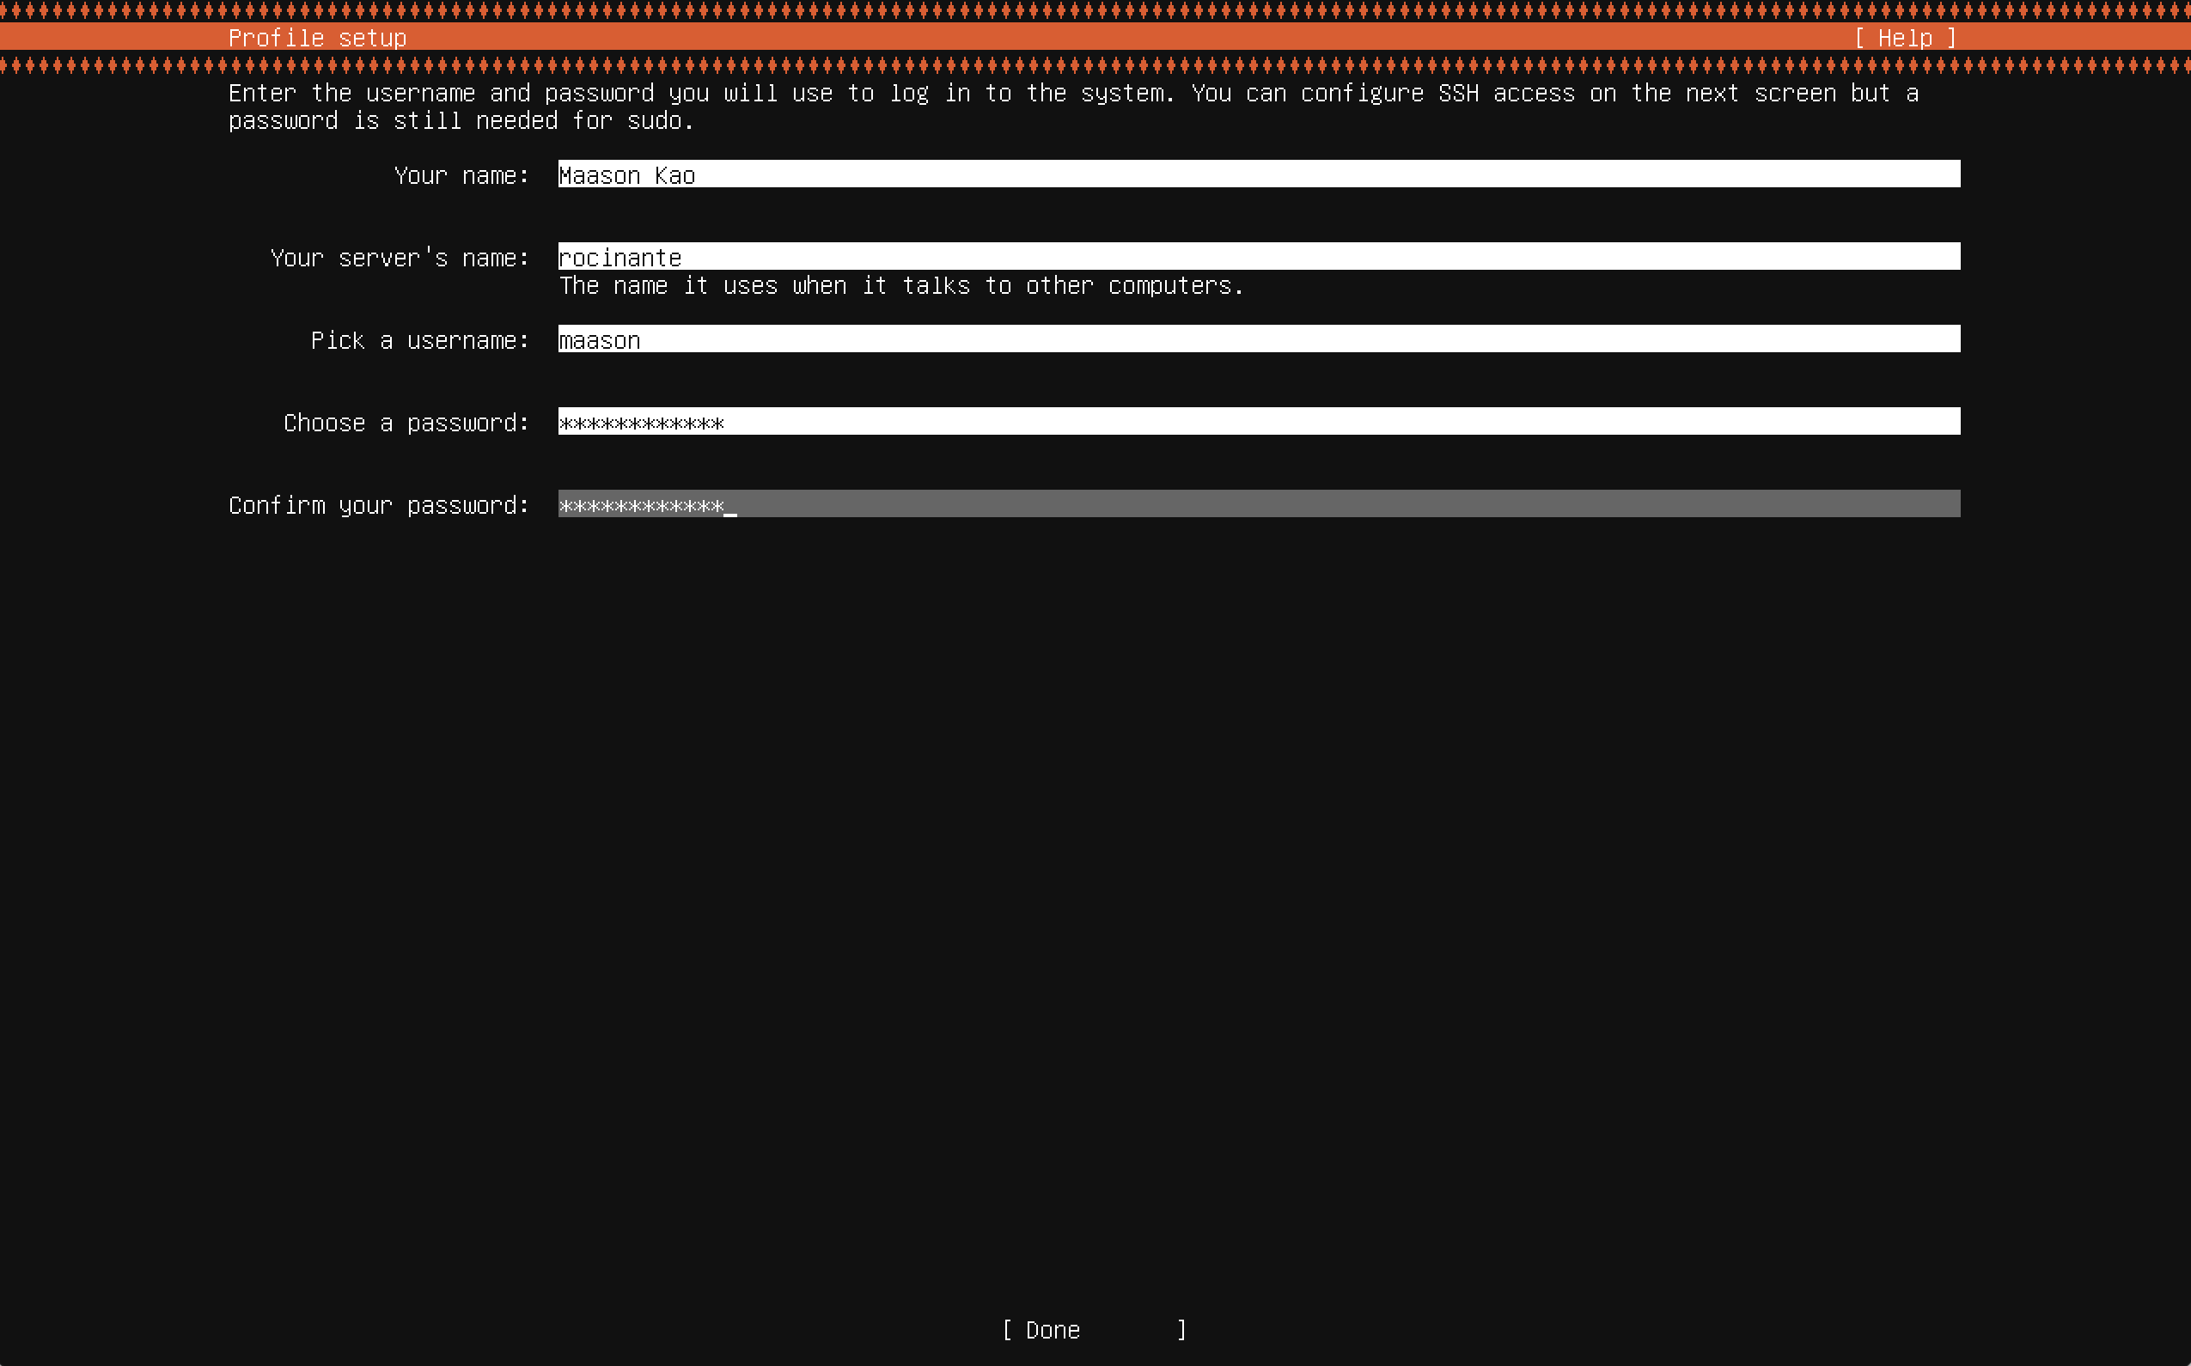
- Accept the default settings of the setup until you reach Profile setup. Fill out the forms. Do not forget your chosen password.
Figure B: Step 11. Remember your password!
- Do not install OpenSSH server or any of the Server Snaps.
- The VM will now begin installation. When the option Cancel update and reboot changes into Reboot Now, go ahead and reboot.
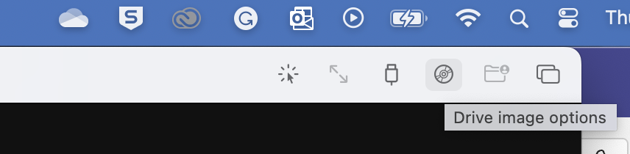
- While the system is rebooting, click on the Disk icon in the top right and eject the CD/DVD iso image.
Figure C: Step 14
- Click on the backwards arrow next to your VM name in the top left to reboot again.
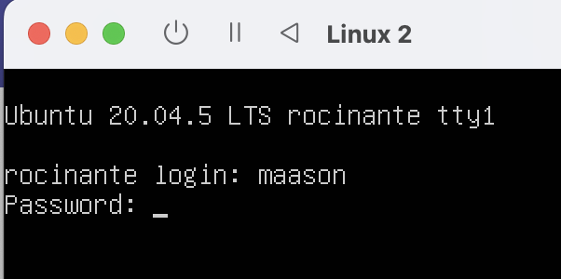
- Enter your username and password from Step 12.
Figure D: Step 15
- Run sudo apt-get update and sudo apt-get upgrade to install updates on your new VM.
- Run sudo apt-get install ubuntu-desktop to install the GUI version of Linux.

